1. PS/2 Mouse and Keyboard Connectors
2. DVI and HDMI Video connectors
3. USB Ports
4. Ethernet Network connector
5. PCIe X1 slot
6. AGP Expansion slot
7. PCI Expansion Slot
8. RAM Slots
9. 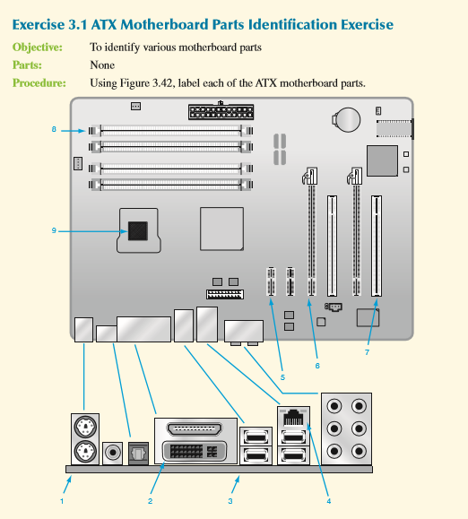Processor